

Week 1 Assessment

**NAME – Dhruv Singh Rathore**

**ROLL NO. – 2001003**

**BRANCH – CSE**

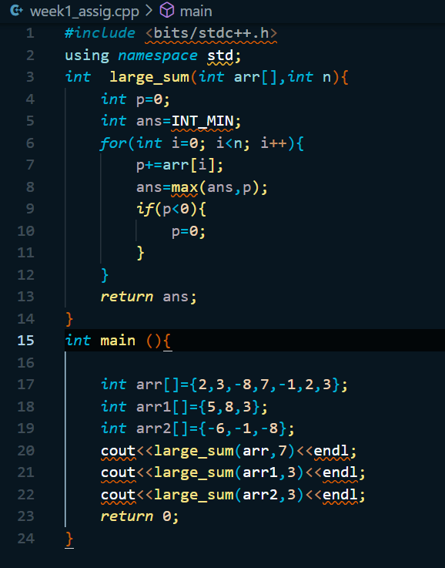Q 1. Given an array arr[] of size N. The task is to find the sum of the contiguous subarray within arr[] with the largest sum. arr[ ] : {2,3,-8,7,-1,2,3} o/p : 11 arr[ ] : {5,8,3} o/p : 16 arr[ ] : {-6,-1,-8} o/p : -1

Q2. Left rotate an array by d.

Output :

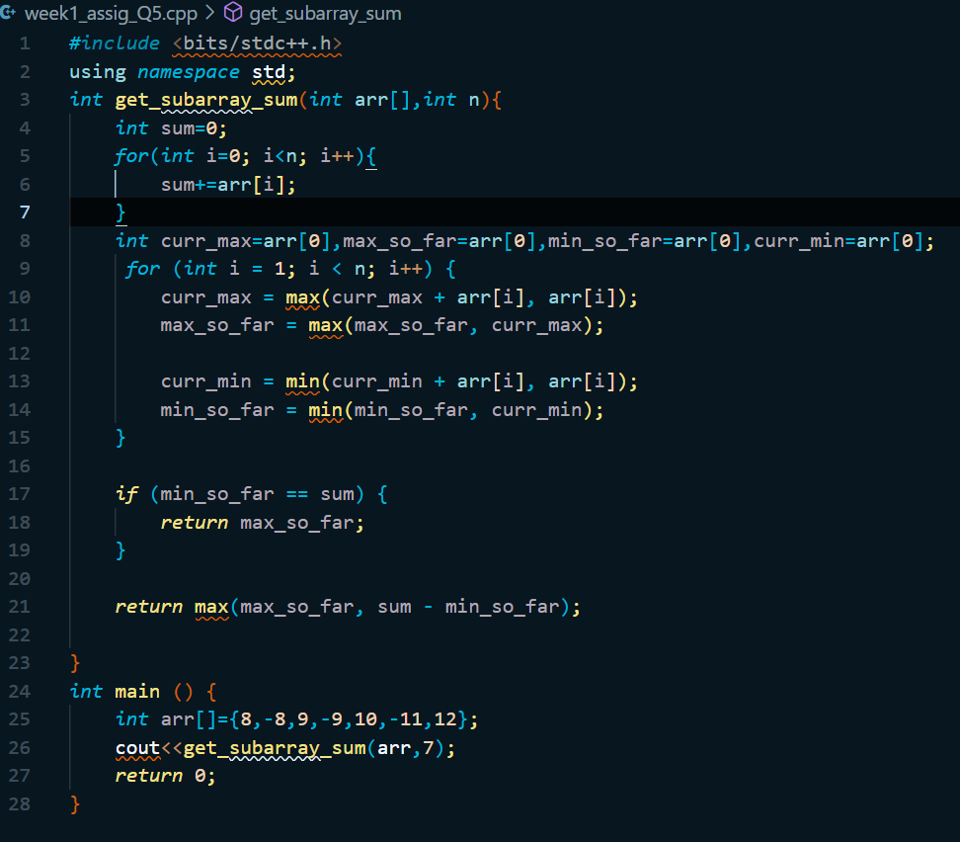

Q3. Print Leaders in an array. An element is a leader if it is greater than all the elements to its right side. And the rightmost element is always a leader.

Output :

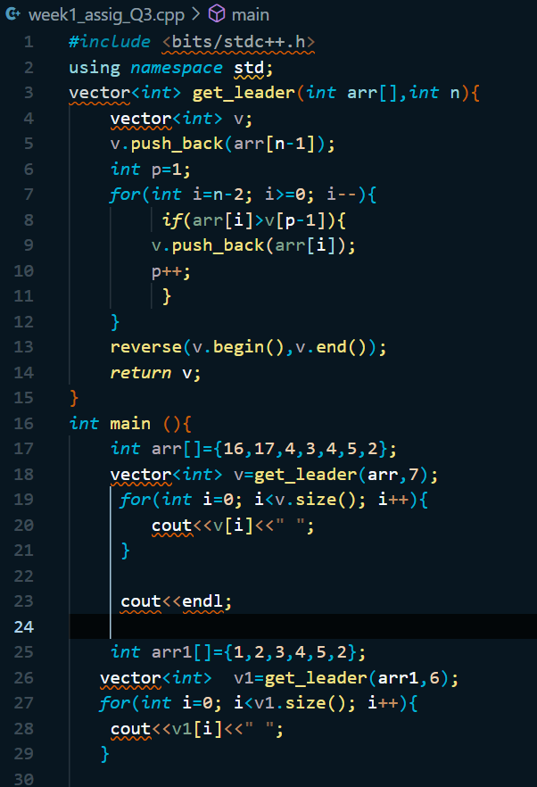

Q4. The cost of a stock on each day is given in an array. Find the maximum profit that you can make by buying and selling on those days. If the given array of prices is sorted in decreasing order, then profit cannot be earned at all. arr[] : {1,5,3,8,12}; o/p: 13 arr[] : {30,20,10}; o/p: 0 arr[] : {10,20,30}; o/p: 20 arr[] : {1,5,3,1,2,8}; o/p: 11.

Output :

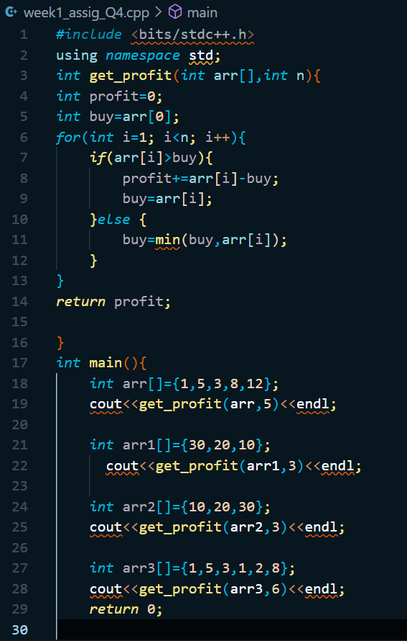

Q5. Given a circular array of size n, find the maximum subarray sum of the non-empty subarray.

Output :

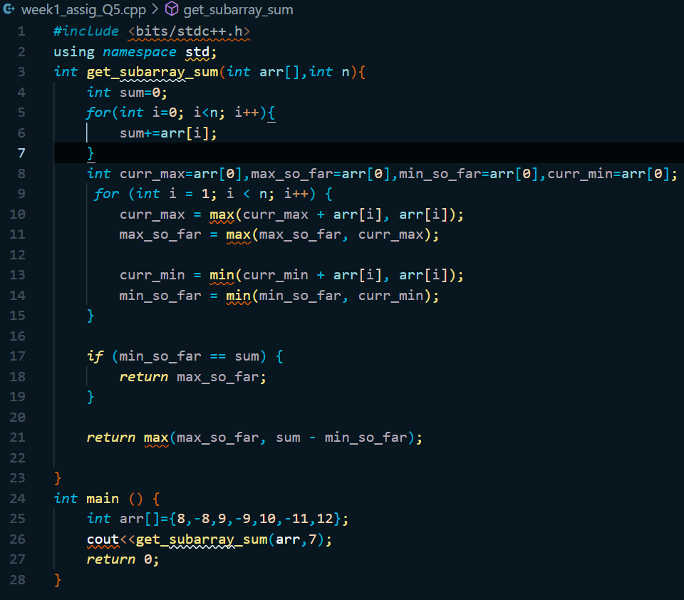

Q7. Given an array. Among all the subarrays from that array of size 3 find that has the maximum sum and print the sum.

Output :

